How Do I Use the New Blocks?
Here are instructions for new blocks in the beta version of Scratch.
Video Sensing | Backdrop Blocks | Clone Blocks | Make Your Own Blocks (Procedures)

Video Sensing
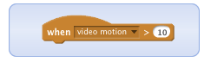
Triggers script when the motion on the current sprite is greater than that number.

How to Use It:
Requires webcam.
It turns on the webcam and keeps checking the motion on the current sprite.
Find this block in the Events category -- the block will look like this:
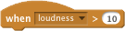

Sample Script:
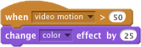

Troubleshooting:
If your webcam isn't turning on, here are things to try:
- Make sure the "Video on" checkbox (under the Stage thumbnail) is checked.
- Make sure no other webcam program is running on your machine (such as PhotoBooth).
- Make sure you have Adobe Flash permissions set to Allow Camera access. To right-click on the top gray menu bar, choose Settings, click Allow). Or visit the Flash site for more info or access the Flash Web Privacy Settings
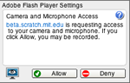
If your webcam won't turn off: To turn the camera off, uncheck the "Video on" box under the Stage thumbnail.

Example Project:
See the project Push the Butterfly.

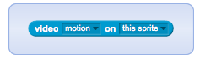
Senses how much motion is currently in the video image. Or, you can sense the direction of the video image.

How to Use It:
Requires webcam.
Use to check the amount of motion in the video under the current sprite.
Use to check the amount of motion over the entire video image.
Use to check the direction of motion in the video under the current sprite.
Use to check the direction of motion in the video image.

Sample Script:
This script lets you interact with a sprite by moving over it in a video image.
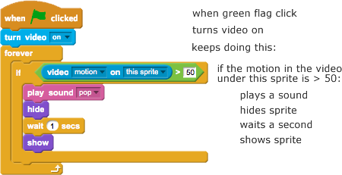

Troubleshooting:
- Make sure the video camera is on.
- Adjust the % of motion or direction to get it to respond more or less.
- Click the checkbox in the Sensing palette to show the current value:
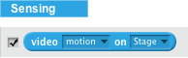

Example Projects:
See the Video Sensing Gallery.

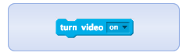
Turns video on and off.

How to Use It:

Requires webcam.
Available in Stage only! In the looks category.
Use to turn on web camera.
Use to turn off web camera.
Use for the video to be flipped (a mirror image).

Sample Script:
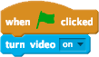

Troubleshooting:
If your webcam isn't turning on, here are things to try:
- Make sure the Video on checkbox (below the Stage thumbail) is checked on.
- Make sure no other webcam program is running on your machine (such as PhotoBooth).
- Make sure you have Adobe Flash permissions set to Allow Camera access (right-click on the Nav bar, choose Settings, click Allow).

Example Project:
See a video camera basics project.

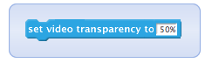
Sets transparency level of the video image on the stage.

How to Use It:
Requires webcam.
Type in a number from 0 (fully visible) to 100 (invisible).

Sample Script:
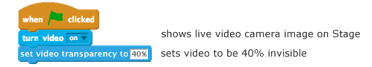

Troubleshooting:
- You'll first need to use this block to turn video on.
- See other troubleshooting for video above.

Example Project:
See a video camera basics project.

Backdrop Blocks (Switch Scenes)

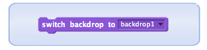
Switches to that backdrop.

How to Use It:
Available from the Looks palette - can be used in sprites or on Stage.
Choose from the menu to select a backdrop name, or the next or previous backdrop:
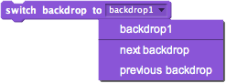

Sample Script:
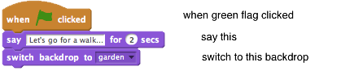

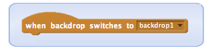
Triggers script below whenever the backdrop switches to the named backdrop. Useful for scenes in a story or levels in a game.

How to Use It:
Available from the Events palette.
Choose the backdrop name from the menu.
To make a new backdrop, click on one of the New Backdrop icons:

Sample Scripts:
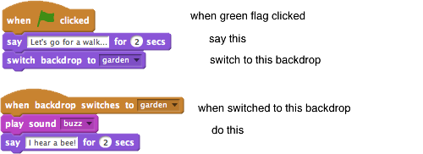

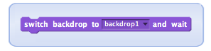
Switches to that backdrop and pauses until all scripts starting with 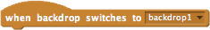are done before continuing. Useful for controlling scenes from the Stage.

How to Use It:
Available from the Looks palette on the Stage only.
Choose the backdrop name from the menu.
This block waits for all scripts that start with to finish before continuing.

Troubleshooting
- Make sure there is no forever block under the "when" hat, or it will keep waiting forever.

Sample Code:

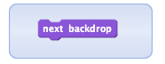
Switches to the next backdrop.

How to Use It:
Available from the Looks palette - works on Stage only.
Identical to using

Sample Script:

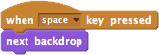

Clone Blocks
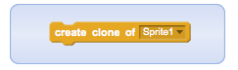
Creates a clone of the specified sprite. (The clone is a duplicate that only lasts while the project is running.)

How to Use It:
Available from the Control palette.
Choose which sprite to clone from the drop-down menu.
The clone appears in the same location as the sprite.
Use to tell the clone what to do once it's created.

Sample Script:
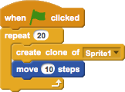

Troubleshooting:
- If you can't see the clone, move it so the original sprite doesn't cover it.
Make sure to choose the name of the sprite you want to clone.

Example Projects:
See the Clones Gallery.

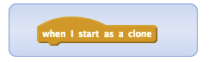
Tells a clone what to do once it is created.

How to Use It:
The block is available in the Control palette.
The script is triggered as soon as the clone is created.
The clone appears in the same location as the sprite, so you need to move it to see it.

Sample Script:
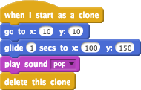

Troubleshooting:
- If you can't see the clone, move it so the original sprite doesn't cover it.
- Make sure you've chosen the sprite you want to clone from the menu in the block.
- Clones also respond to all "when..." blocks triggered after they are created.

Example Projects:
See the Clones Gallery.

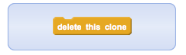
Deletes the current clone.

How to Use It:
The block is available in the Control palette.
Place this block in a script after the clone is done its actions.
All clones are automatically deleted when the program is stopped.

Sample Script:

Example Projects:
See the Clones Gallery.

Make Your Own Blocks

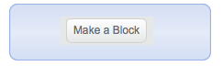
Name your own block and then define what it does using a script. (Also known as making a procedure.)

How to Use It:

1) Click in the More Blocks... category. Type in a name for your block, such as "jump":
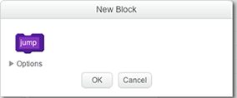
This will make a new block in the palette and a define block in the Scripts area.

2) Make a script under 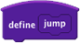 to tells what the block will do.
3) Now you can use your block in any script within that sprite.
4) Optional: If you want to add inputs (also known as parameters):
•Click Options.
Or, you can right-click (Ctrl+click for Mac) on and select from the menu.
• Click for a number, for text, and for a boolean parameter. You can edit the name to describe the input (such as "number of times" or "how much").
• A lighter purple block (for example, ) will appear in the define block. You can drag copies of that input block into other blocks within the define script.

Sample Scripts:
You can use a new block to make your scripts more organized and modular:
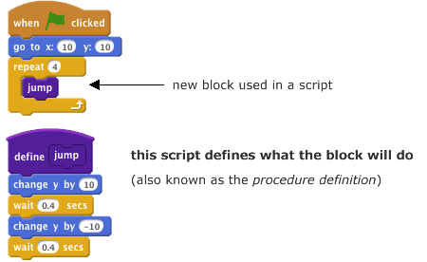
Here's an example of a new block with an input (parameter):
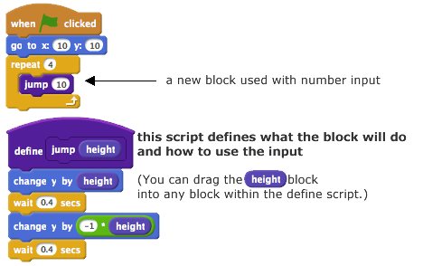

Troubleshooting:
- You need to have a define script to tell your block what to do. Keep the define script (don't throw it away).
- You can only drag inputs (parameters) into blocks that are attached to the define script!
- Right-click to edit the name of the block or add or delete parameters.

Example Projects:
See the Make a Block gallery.

